# TA Classifieds

**Overview:**

Here we are providing a chance to TA Employees to post their AD's are messages to all the employees.

**Pages**

**Home Page**

Home page contain general information and links to login/signup screen as follows

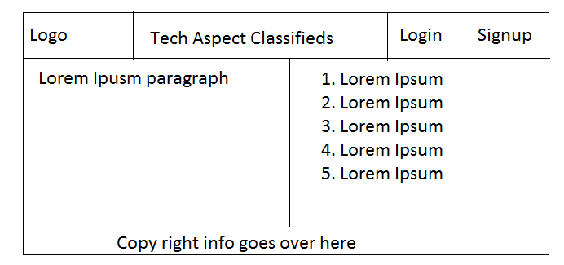

**Login Page**

Screen As follows

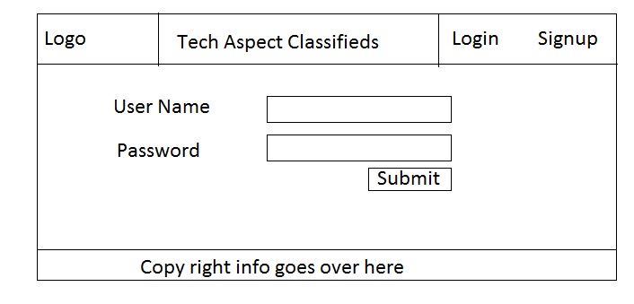

**Sign up**  
 Screen As follows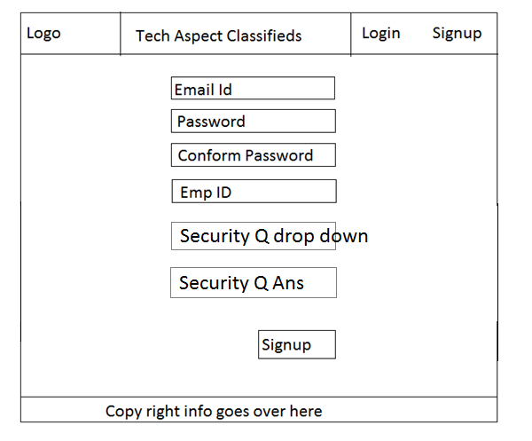

**Classifieds Page**

By default we are show All classifieds we have to disable link to all classifieds. If user clicks on other menu item needs to enable the selected link and other links has to enable. In future few more options will be added to menu like change password etc. If user clicks on any one of the classified form the list needs to show the full details of the classified.

Screen shot as follows

